# Relational Databases

**Relational Database**

Is where data is stored in separate tables that are linked through the use of primary and foreign keys. Each table stores data about a single entity.

**Flat File Database**

All data stored in a single table.

**Primary Key**

Is a field within a database which enables every record to be uniquely identified.

**Foreign Key**

A field in a table that is a primary key field in another table.

**Secondary Key**

Used to locate one (or more) records - it is different from the primary key because a primary key is guaranteed to return a single record whereas a secondary key may return more than one record.

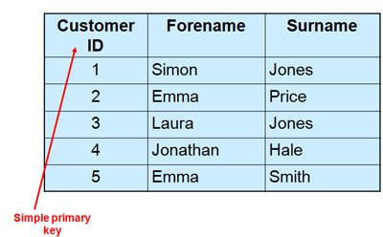

An entity is a thing that can be distinctly different. Ie STUDENT, SUBJECT, TEACHER.

An ERD is a planning tool for designing the structure of a relational database.

There are 3 types of relationships:

- One-to-one.

- One-to-many.

- Many-to-many.

One to one

- Uncommon in a relational databse.

- EMPLOYEE to NIN

- HUSBAND to WIFE

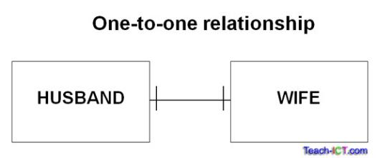

One to Many

- Most common type.

- LIBRARY MEMBER to LOAN.

- CUSTOMER to ORDER.

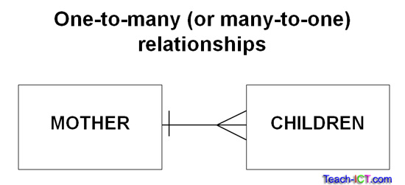

Many to Many

- Many to many relationships should not exist in an efficient relational database.

- If you have many-to-many relationships a link must be added.

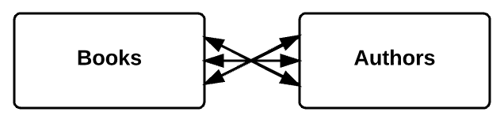

This shouldn’t exist.

**Normalisation**

- Process used to design relational databases in an efficient way is called **normalisation.**

- There are different forms of normalisation.

- First Normal Form (1NF)

- Second Normal Form (2NF)

- Third Normal Form (3NF)

- There are more but they’re not on the course.

- There are **specific rules** for each normal form I must know.

**First Normal Form (1NF)**

1. Eliminate duplicate columns from the same table.
2. Create separate tables for each group of related data.
3. Have primary keys to uniquely each row in tables.

**Second Normal Form (2NF)**

1. Data must be in 1NF.
2. Remove any data sets that occur in multiple rows and transfer them to new tables.
3. Create relationships between these new tables and the older tables by use of foreign keys.

**Third Normal Form (3NF)**

1. Data must be in 2NF.
2. Remove any columns that are not dependent on the primary key.
3. Must depend on the WHOLE key.

**Queries and Reports**

- A **query** is used to extract a **subset** of the data in a database.

- Queries can combine data from more than one table and present data in whatever order is required.

- Queries can be used to perform calculation.

- The results of a **query** can be presented in a **report.**

**- Reports** are used to present information in a user friendly format - they can be set up to summarise, group and select data.

**Queries**

- Parameter queries are used in databases to search for information that meets certain criteria.

- The parameter is the criteria used to select records.

- Static parameter queries have the parameter hard coded.

- Dynamic parameter queries ask the user for the value to search for by creating a dialogue box for them to enter a value.

- This makes the query more flexible and saves having create a large number of hard coded queries.

**DBMS (Database Management System)**

- Software that creates and maintains a database.

- Jobs include the creation and use of:

- database structure.

- queries.

- views.

- individual tables.

- interfaces.

- outputs.

**Database Views**

- Data held in a database can be envisaged at three levels or ‘views’.

**Physical View**

- How the data is actually recorded in the storage medium. This level of understanding needs to be achieved by software so that storage is correctly managed but not necessarily by the user.

**Logical View**

- Concerned with how the data is organised for processing.

- Looks at the construction of tables, queries, reports and software that will deliver functionality to the owners of the system.

- Constructing this level involves the creation of a **data dictionary.**

**User View**

- About appearance and functionality of the database. The user is not concerned about the structure of the database just needs to access whatever data they need for their job.

**Data Dictionary:** metadata; data about data. Will contain all the information about the structure of the database including the relationships, fields and tables.

**Transaction Processing**

- Type of processing that attempts to provide a response to a user within a quick time frame.

- Not as time critical as RTS and normally has a limited range of operations planned in advance such as bank balance or withdrawal.

**CRUD**

All databases must have certain basic functionality to be useful. This is remembered by the acronym CRUD.

**C -** Create

**R** - Read

**U -** Update

**D -** Delete

Which are mirrored by the SQL statements:

- INSERT/CREATE

- SELECT

- UPDATE

- DELETE

Three of these result in a transaction taking place.

Transactions must not allow a database to become damaged.

**Data Integrity:** The maintenance of a state of consistency in a data store. This means the data in the store accurately reflects the reality it is trying to represent. Data is as intended and fit for purpose.

**Data Corruption:** Opposite.

**Data Security:** Keeping data safe.

**Referential Integrity:** Part of Data Integrity refers to a state where inconsistent transactions are not possible.

**The ACID Rules**

Set of rules to protect the integrity of a database. Remembered by acronym ACID.

**Atomicity:** Change in a database is either completed fully or not at all. Software must prevent a half finished transaction being made.

**Consistency:** A transaction must take the database from one consistent state to another.